South China University of Technology
《Software Engineering》Experiment Report
Experiment Title： UML of Hospital ward monitoring system
Name： 杨竣尧/谭演锋 Student ID： 202130442068/202130100456
Class： 21计联 Group： /
Collaborator： /
Teacher： 李剑
Description
【Objective and Requirement】
Objective：
Description of the Problem:
In the hospital ward, symptom monitors are placed at each bedside to monitor patients. These monitors transmit real-time symptom signals (aggregated) to the central monitoring system for analysis and processing. In the central duty room, the duty nurse uses the central monitoring system to monitor the condition of patients. The monitoring system continuously compares and analyzes the patient's symptom signals with standard diagnostic signals in real-time. When symptoms deviate from the norm, the system automatically raises an alarm, prints a medical condition report, and updates the medical records. The system can print patient medical condition reports at any time upon the doctor's request, and it also automatically updates medical records on a regular basis.

Simple Requirement Analysis Overview:
1. The symptom monitor can collect symptom signals (aggregated), format them, and transmit them in real-time to the central monitoring system.
2. The central monitoring system compares the patient's symptom signals with the normal values of symptoms in the standard symptom signal library. The system automatically raises an alarm when symptoms deviate from the norm.
3. In the event of abnormal symptom signals, the system automatically updates the medical records and prints a medical condition report.
4. Duty nurses have the ability to view and print medical condition reports.
5. Doctors can view medical condition reports, request the printing of reports, and also have the option to view or request the printing of complete medical records.
6. The system performs regular automatic updates to the medical records.

Requirement：
- Draw a use case diagram for the monitoring system. To show the monitoring system’s functions and how it interacts with external entities. Should be drawn in the form of “Use case diagram” in Rational Rose
- Draw a block diagram of a possible architecture for such a system. Should identify the principal sub-systems and the links between them. Should be drawn in the form of Packages in “Class diagram” in Rational Rose (Packages and components)
- Draw a sequence diagram for the Monitoring System. To show the process of Monitoring. Should be drawn in the form of “sequence diagram” in Rational Rose
- Draw a state machine diagrams for the Monitoring System. Show the states and state transitions of monitoring system. Should be drawn in the form of “state machine diagram” in Rational Rose
- Draw a class diagram for the Monitoring System. Identify the main classes in the monitoring system. Identify the relationships between classes. Should be drawn in the form of “class diagram” in Rational Rose

【Environment】
Operating System：Windows 10/MacOS
Content
【Procedure】
- Step：
After analyzing the requirement, we identified 4 main actors and its responsibilities and requirement supporting.
- Patient: Provide symptom signals(Generate and convey timed symptom signals ).
- Doctor: Take care of patients and deal with symptoms deviation. Need the monitor system supporting to finish the tasks. Be interested in the monitor system running results.
- Nurse: Monitor the patients’ symptoms changing. Need to use the monitor system’s main functions. Be interested in the monitor system running results.
- Standard Symptom Signal Library: Provide normal symptom’ signals. Should keep the system work normally. Integrate with the systems.

Then we also need some classes and functions to help us develop the system.
- Central Monitor
Decompose the signals: Decompose the aggregated symptom signals transmitted from the symptom monitor into signals that the system can process.
Compare signals: Compare the patient's symptom signals with standard signals.
Alarm: If the symptom signals deviate from the normal range, specifically exceeding the peak value, an alarm signal is triggered.
Format Symptom Signals: Format the processed data for writing into the medical records database.
- Symptom Monitor
Symptom Signal Acquisition: Collect the symptom signals from the patient.
Analog-to-Digital Conversion: Convert the collected analog signals into digital signals.
Symptom Signal Aggregation: Combine the collected signals data, such as pulse and blood pressure, into a set of signal data
Change Sampling Frequency: Adjust the monitor's sampling frequency based on the patient's condition.
- Medical Record:
Generate Medical Record
Update Medical Record
Display Medical Record
Print Medical Record
- Represent Medical Report:
Display Medical Record
Print Medical Record: Print the medical condition report on the printer.

- Major Procedure：
- Use Case Diagram
Draw a use case diagram for the monitoring system to show the monitoring system’s functions and how it interacts with external entities.
The diagram should be drawn in the form of “Use case diagram” in Rational Rose
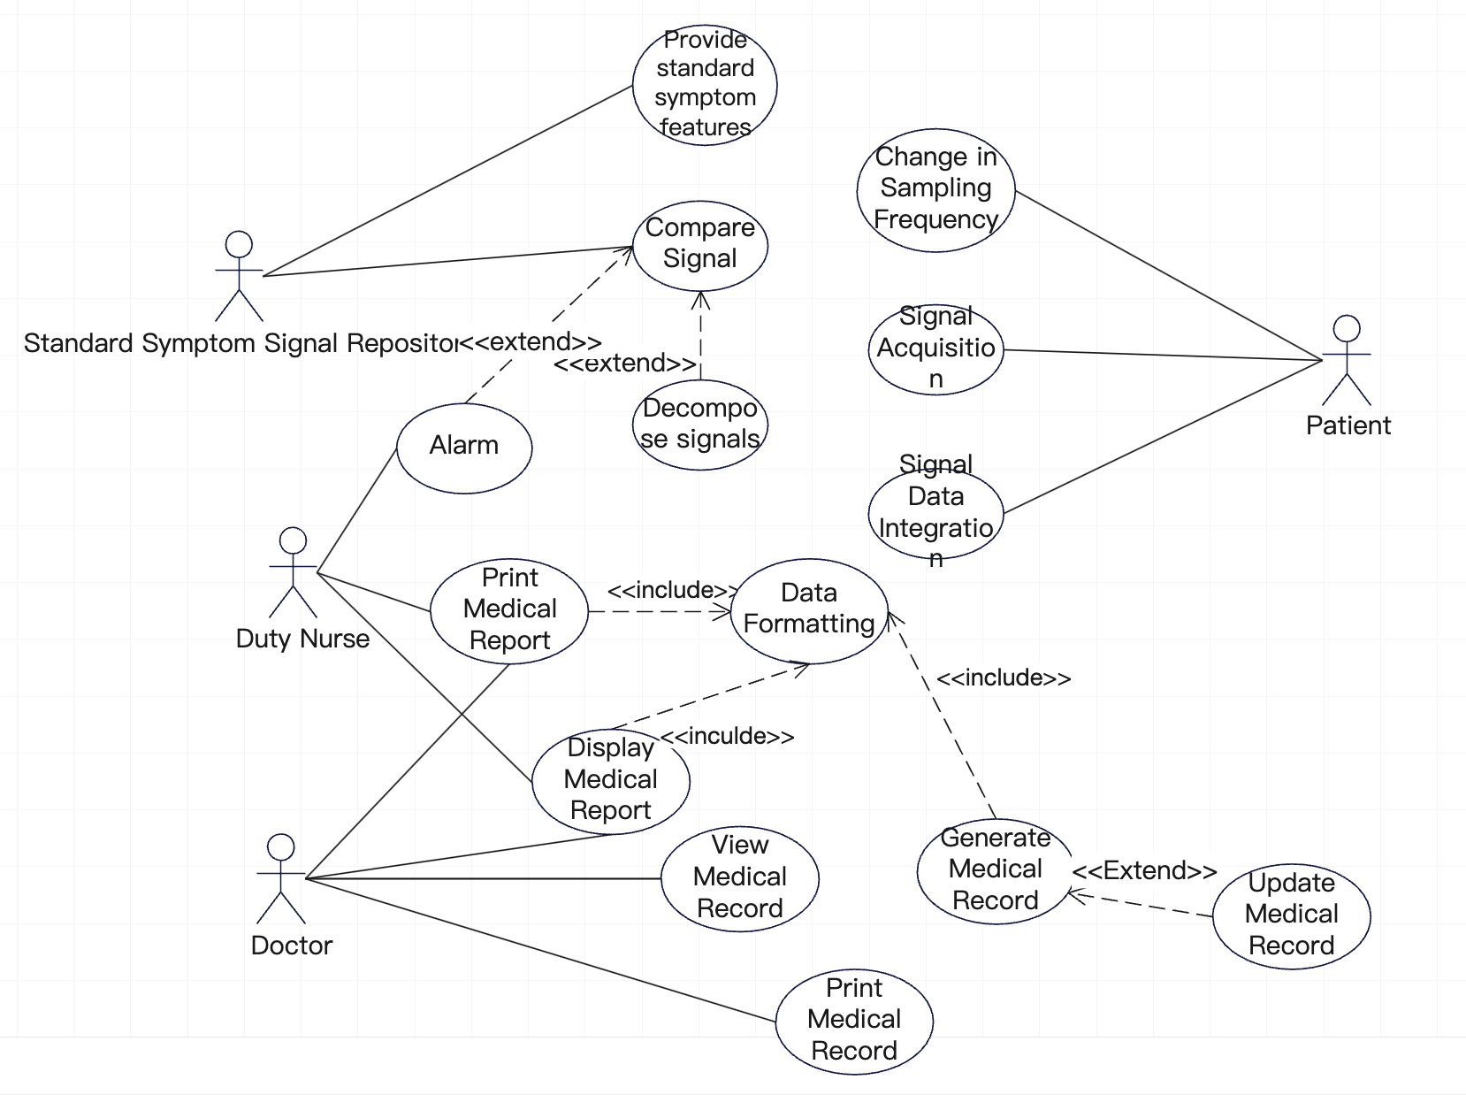
Fig 1. Use Case Diagram of Monitoring System

The use case diagram depicts the "Monitoring System" within a central boundary. The Use Case Diagram has 4 key actors "Standard Symptom Signal Repository," "Patient," "Nurse," and "Doctor." Various use cases, such as "Data Formatting," "Decompose signals," and "Signal Data Integration" outline the system's functionalities. Actors interact with these use cases, representing their roles in the monitoring process. Lines connect actors to use cases, illustrating their involvement in specific functionalities. Relationships, including "include" and "extend," detail connections between use cases, such as the integral role of updating medical records in generating reports.
In summary, the diagram visually outlines how external entities interact with the Monitoring System, showcasing essential functionalities and relationships to facilitate patient monitoring and medical record management.

- Packages Diagram
Draw a block diagram of a possible architecture for such a system.
The diagram should identify the principal sub-systems and the links between them and it should be drawn in the form of Packages in “Class diagram” in Rational Rose (Packages and components)
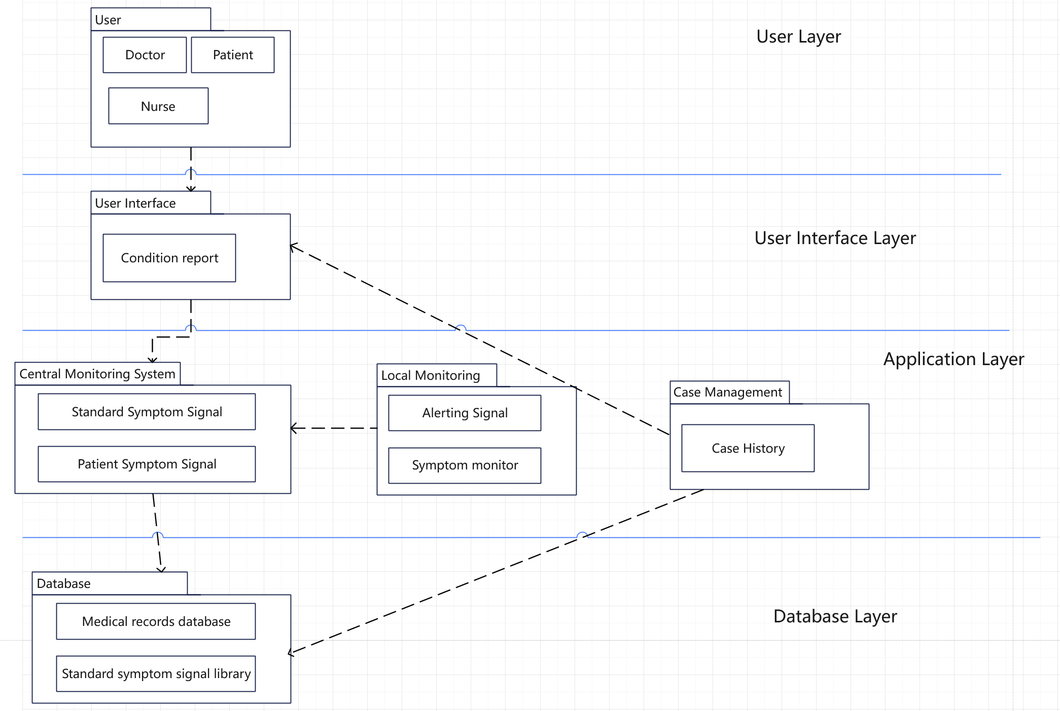
Fig 2. Use Packets Diagram of Monitoring System

The packet diagram serves as a visual representation elucidating the intricate data flow and communication structure intrinsic to the monitoring system. In this schematic depiction, packets, acting as carriers of specific information such as patient symptom data, report requests, and medical record updates, traverse defined pathways within the system. These packets seamlessly travel between monitoring devices, the central monitoring system, and end-users like nurses and doctors, portraying a dynamic illustration of the system's data exchange mechanisms. This visualization effectively captures the system's ability to manage and convey critical information, ensuring real-time monitoring and facilitating prompt medical interventions based on the transmitted data.
In essence, the packet diagram encapsulates the robustness of the monitoring system's data flow, providing a concise yet comprehensive overview of how packets navigate through various components. This clarity is crucial for understanding the system's responsiveness and its efficacy in healthcare monitoring, showcasing the orchestrated exchange of information that underpins the seamless operation of the monitoring infrastructure.

- Sequence Diagram
Draw a sequence diagram for the Monitoring System to show the process of Monitoring.
The diagram should be drawn in the form of “sequence diagram” in Rational Rose

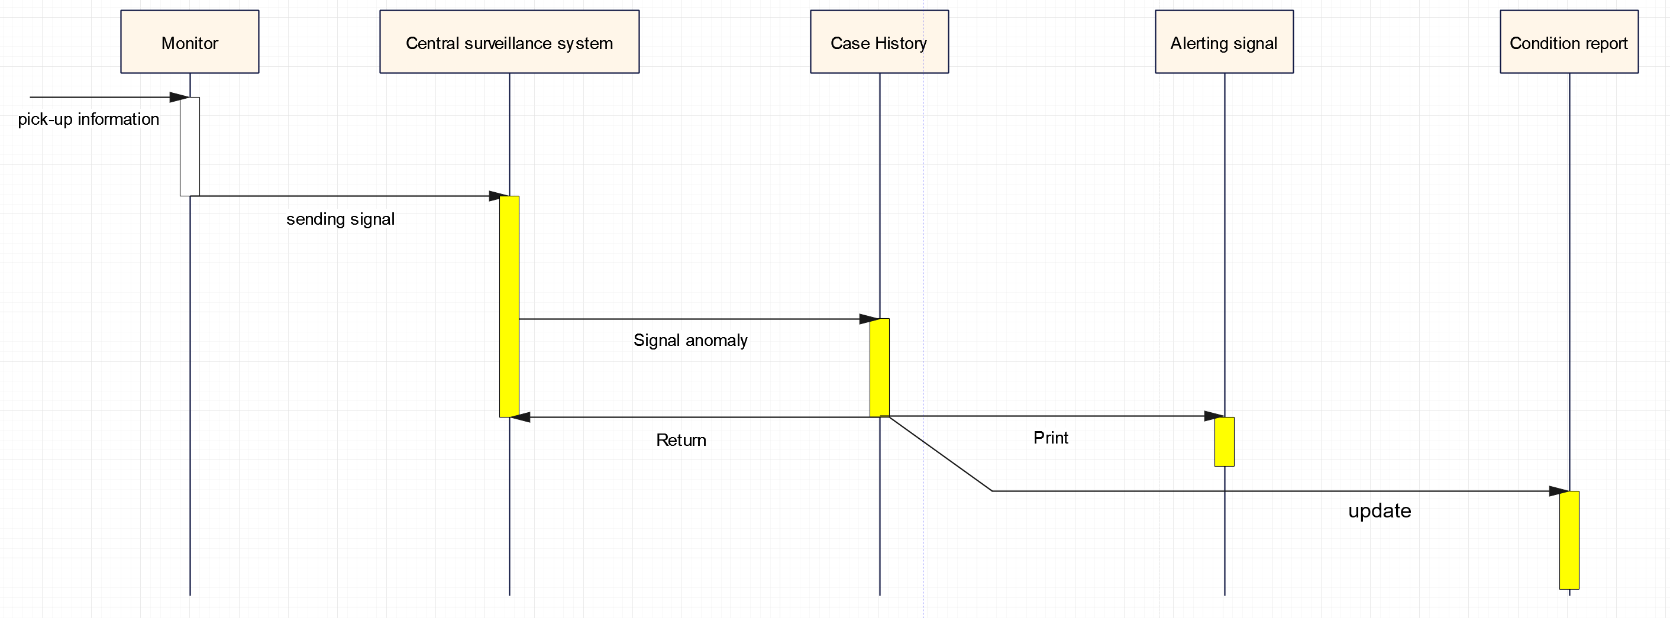
Fig 3. Sequence Diagram of Monitoring System

The sequence diagram for the monitoring system illustrates the chronological flow of interactions among components. It begins with the initiation of a monitoring session, capturing patient symptoms, and transmitting data to the central monitoring system. Upon analysis, if an anomaly is detected, an automatic alert triggers the generation of a medical report and updates to the patient's records. Nurses and doctors can interact with the system by requesting reports or viewing patient information, initiating further communication and data exchange. This succinct visualization encapsulates the real-time collaboration and information flow in the monitoring process, from data capture to healthcare professional interactions.

- State Machine Diagram
Draw a state machine diagrams for the Monitoring System and show the states and state transitions of monitoring system. The diagram should be drawn in the form of “state machine diagram” in Rational Rose.
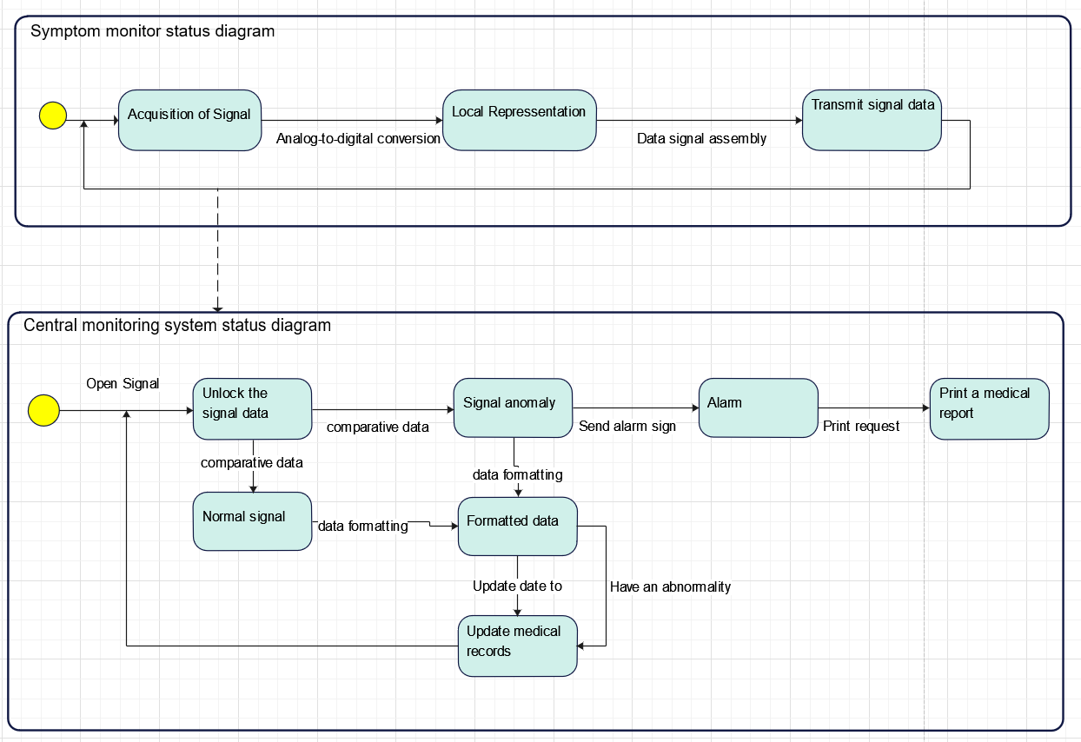
Fig 4. State Machine Diagram of Monitoring System

- Class Diagram
Twelve classes of the system can be identified by noun recognition method and system entity recognition method. The following simple and clear method is used to express the name, attribute and operation of the class respectively. See the picture below:
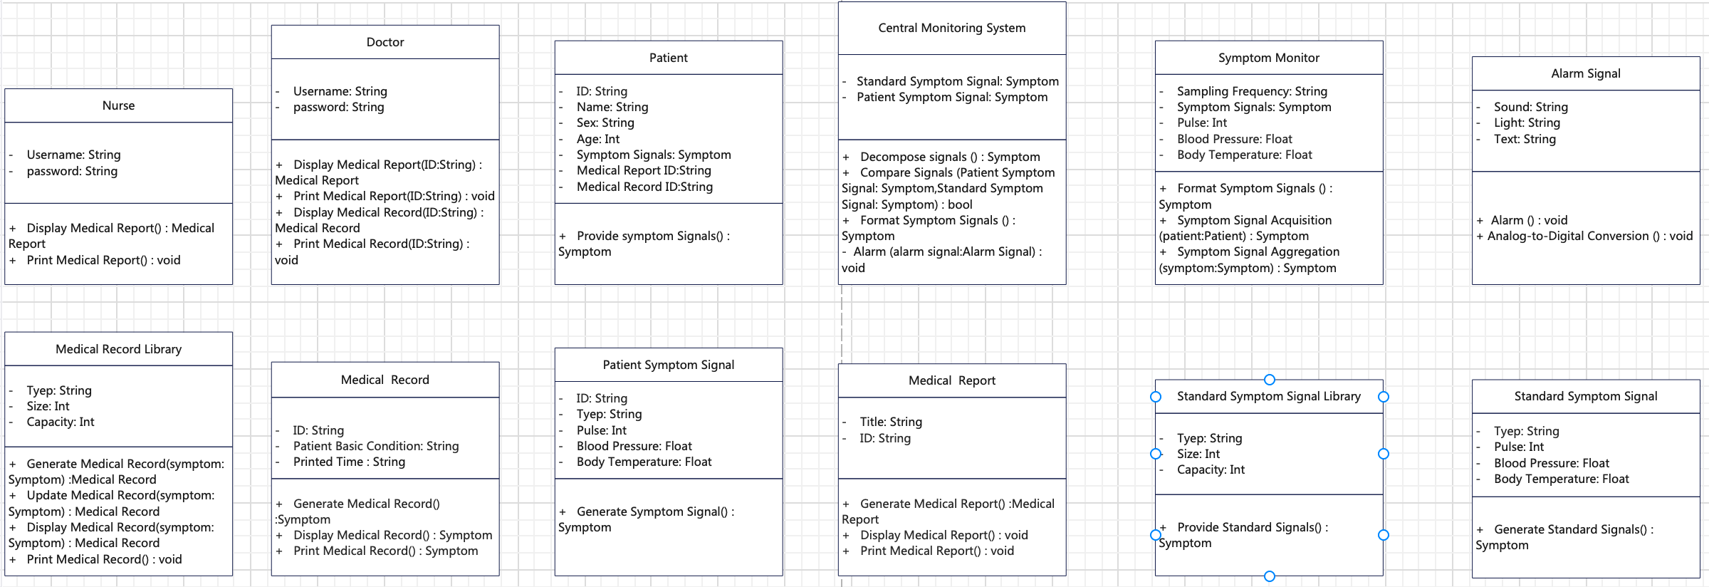
Fig 5. Classes of Monitoring System

Further indicate the relationships between classes in the class diagram:
The diagram should identify the main classes in the monitoring system and identify the relationships between classes.
The diagram should be drawn in the form of “class diagram” in Rational Rose.
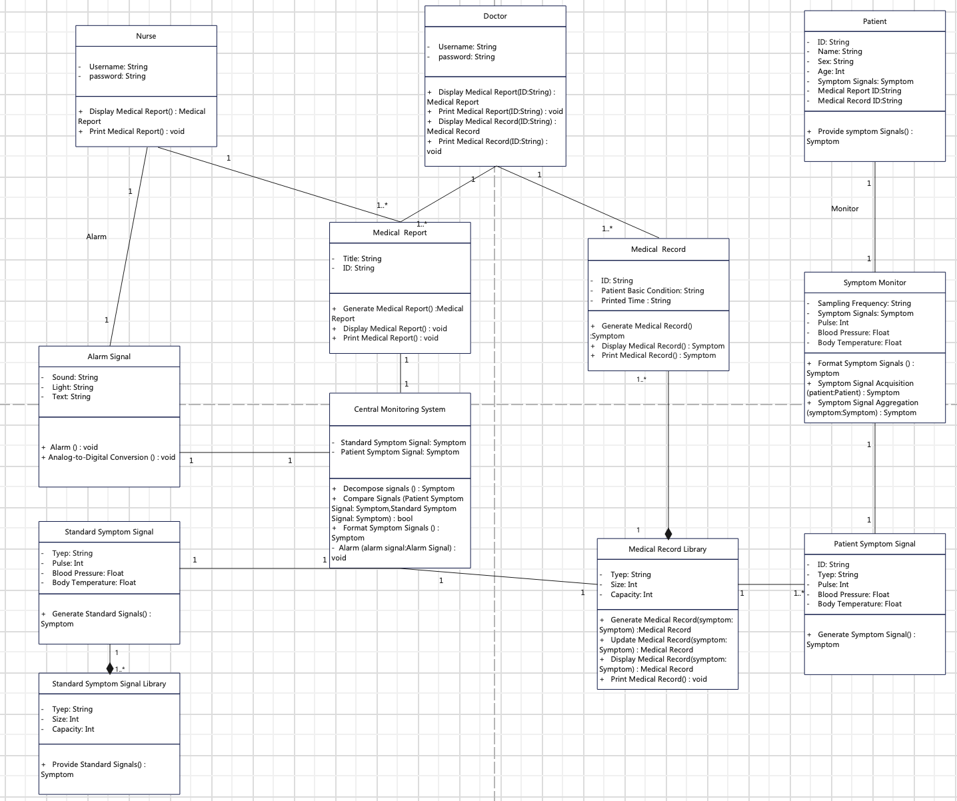
Fig 6. Class Diagram of Monitoring System

The classes diagram for the monitoring system outlines the key entities and their relationships in the system's object-oriented design. Classes like "Doctor," "Central Monitoring System," and "Patient Symptom Signal" encapsulate attributes and behaviors, showcasing the structural foundation of the system. This diagram serves as a concise blueprint for developers, facilitating a clear understanding of entity connections and aiding in the implementation of a modular and well-structured monitoring system.
Conclusion
In conclusion, the designed hospital ward monitoring system successfully meets the specified requirements. The use case diagram highlights key functions and interactions, emphasizing real-time symptom monitoring and automatic alarm generation. The package diagram illustrates a well-organized architecture, with distinct sub-systems like symptom monitors, central monitoring, and interfaces for duty nurses and doctors. The sequence diagram captures the dynamic process of symptom monitoring, while the state machine diagram depicts system states and transitions. The class diagram identifies main classes and their relationships, ensuring a clear representation of the system's structure. Overall, the visualized system provides an integrated solution for efficient patient symptom monitoring and medical record management in a hospital setting.
After this experiment, we have learned how to translate a specified requirement into the UML. We learn how to analysis the requirement and design the function of the system step by step. Then we decompose the system, and design the interaction between the sub-system. Finally, we draw the UML, which can largely help us truly develop a system.
Teacher’s Comments and Score
Comment：

Score： Signature：
Date：

